Topic 2: GEOMETRIC CONSTRUCTION
The understanding of the basic formation of various 2-D shapes lay the foundation for the deduction of the component parts of bigger, more complex 3-D shapes. With the emphasis on the simplistic formations of the angles and sides of common plane shape, the concept is easily extended to lager solid shapes.
Objectives:
At the end of the lesson, the students will be able to:
- Construct basic angles and bisect line segments.
- Construct triangles and quadrilateral polygons.
- Extend basic constructions to construct equilateral triangles.
In the construction of basic angles, the most important tool is the mathematical tool set that will be utilized in great detail.
- 180 DEGREES (LINE SEGMENTS)
This is the total sum of angles on a straight line; in other words, to construct the 180 degrees angle, it suffices to draw a completely straight line of any length and without bisections. This can be done and measured with protractor.
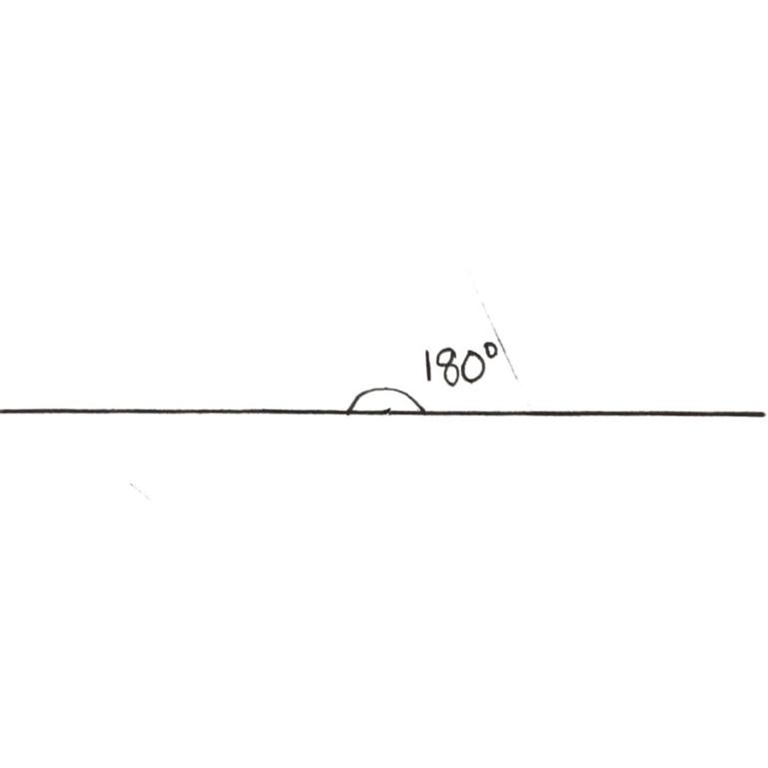

- 90 DEGREES (BISECTION OF LINE SEGMENT)
To construct the 90 degrees, it suffices to bisect the 180-degree angle into two equal parts. Since we will be splitting the angle into two equal parts, it follows that whatever length we have must also be bisected at its midpoint. This will be done with the aid of the compass.
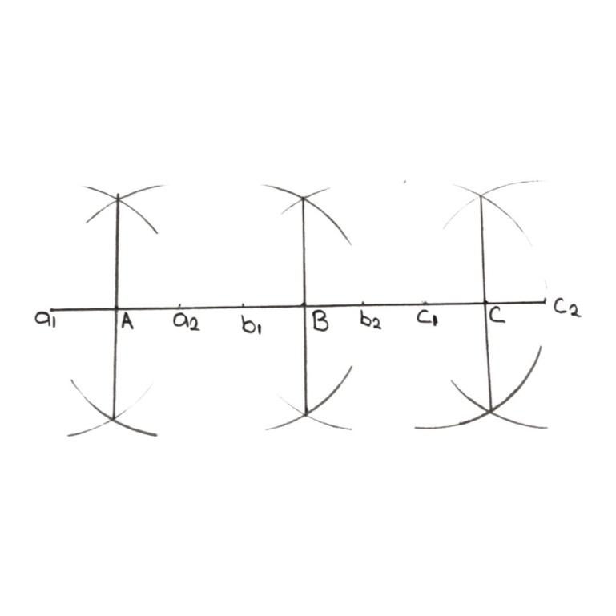

To construct the 90$°$ angle, choose the angle point. (in this case we choose A, B and C as points).
- On each point, place the ruler and ensure an equidistance, such that the angle point becomes the midpoint of the equidistance. ALTERNATIVELY, instead of using the ruler, place the compass on the angle point (A, B or C) and make two arcs that will be equidistant from the angle point.
For point A, $a_{1} and a_{2}$ are the arcs;
For point B, $b_{1} and b_{2}$ are the arcs;
For point C, $c_{1} and c_{2}$ are the arcs;
- Now extend the compass such that the tips rest on the ends of the equidistance deduced in step 2 (I.e. $a_{1} and a_{2};$ $b_{1} and b_{2}; c_{1} and c_{2}.$
- Draw arcs on the top and bottom positions. swap the compass tips and intersect the arcs at the top and bottom. i.e. with the pencil tip resting at $a_{1} and the metal tip a_{2}$, draws arcs on top and bottom.
Then with the pencil tip resting at$a_{2}$ and the metal tip at $a_{1},$intersect the arcs on top and bottom.
- Draw a straight line to join the two intersect points, the resulting angle at the angle point is exactly 90$°,$ measurable by protractor.
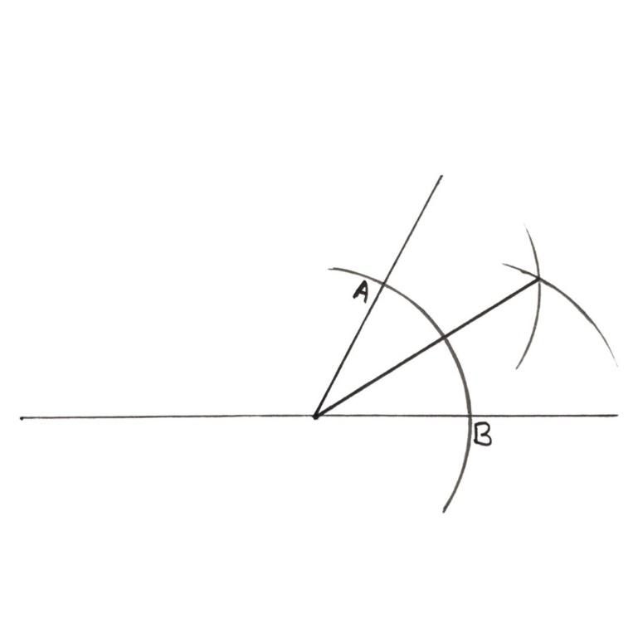

DIVISION OF ANGLE INTO TWO EQUAL PATRS
- From the base angle and angle point, choose a distance stretch on the compass and make an arc cutting the two lines of the base angle (as shown by points A and B).
- At intersection point A, place the metal tip and make an arc, then move the metal tip to intersection point B and intersect the first arc.
- Draw a straight line to connect the new intersect with the base angle point. Each part will now be exactly half of the base angle, measurable by protractor.
CONSTRUCTION OF TRIANGLES
To construct the basic triangle, one of three methods is applicable.
METHOD 1: THREE KNOWN SIDES
Example:
Using a ruler and a pair of compasses, construct a triangle ABC, such that AB= 3cm, BC= 4cm and AC= 5cm.
- Draw the base line with length equal to given value. (i.e. AC = 5cm)
- From point A, extend the pencil tip of the compass to a length of 3cm and make an arc.
- From point C, extend the pencil tip of the compass to a length of 4cm and make a second arc that intercepts the arc in ii. Mark the interception as point B.
- Join the lines AB and BC, and label as appropriate.
TRIVIA: if you construct a Pythagorean triple, one of the angles in the resulting triangle will be 90$°.$
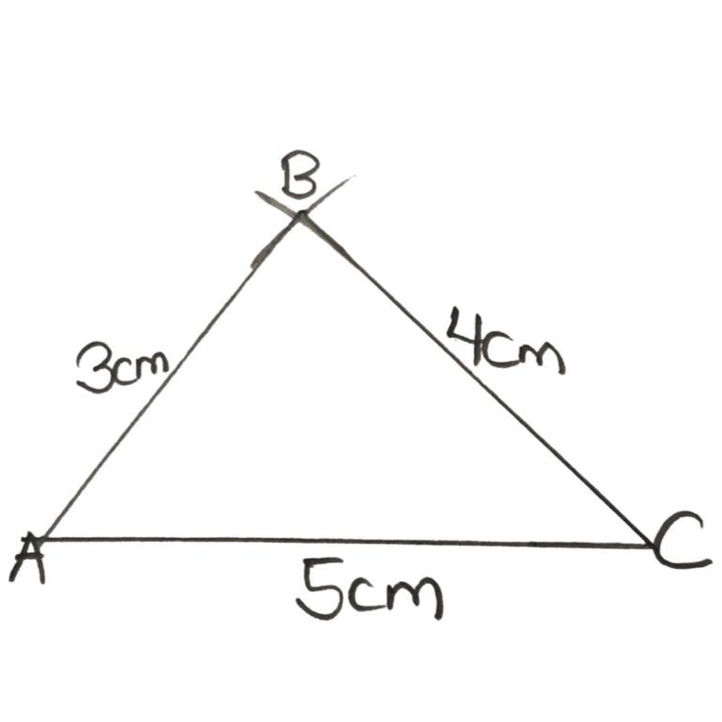

METHOD II: ONE KNOWN SIDE AND TWO KNOWN ANGLES
Example:
Using a ruler and a pair of compasses, construct a triangle ABC such that <ACB = 30$°$, <ABC = 60$° and$BC= 10cm.
Trivia: It is most important that known side is the side in between the two known angles.
- Draw the known side as the base line (i.e. BC = 10cm)
- At B, construct an angle of 60$°$, join the line to B and extend it
- At C, construct an angle of 30$°$, join the line to C and extend it
- The intersection of the two lines in II and III gives us point A.
TRIVIA: To construct 60$°$ at B
- Open the compass with metal tip at B to any length within BC, and make an arc. (call the point $b_{1}$)
- Maintaining the length in $a_{1}$ proceed to make intersecting arcs at B and $b_{1}$
- Connect the intersection point to B.
TRIVIA: To construct angle 30$°$, bisect angle 60$°$ equally.
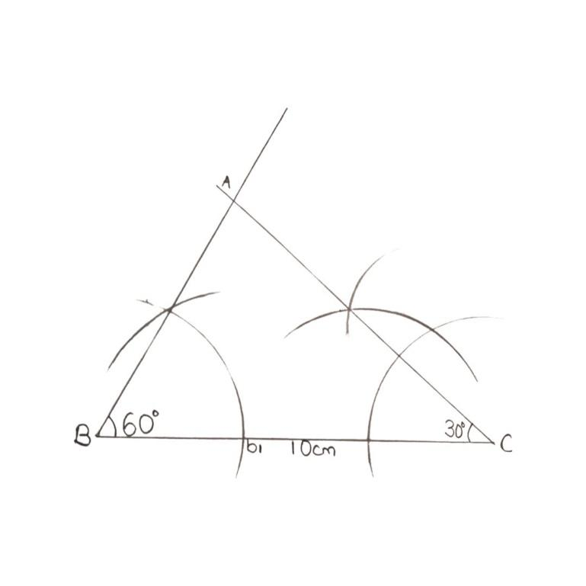

METHOD III: TWO KNOWN SIDES AND ONE KNOWN ANGLE
TRIVIA: It is most important that the known angle is the angle in between the two known sides.
Example:
Using a ruler and a pair of compasses, construct triangle XYZ such that <XYZ = 60$°$ while XY = 6cm and YZ= 8cm
- Choose one of the sides as the base line (in our case, XYZ)
- At Y, construct 60$°,$ while maintaining the length of 6cm on the ruler, when joining the line, the end point gives point X
- Join points X and Z to complete the triangle.
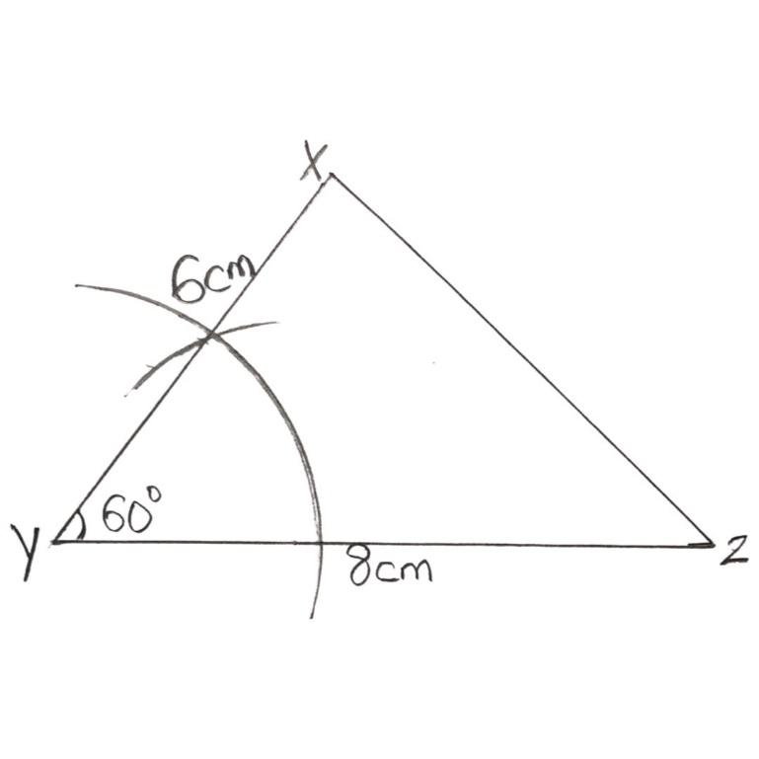

CONSTRUCTION OF QUADRILATERALS
Quadrilaterals or Quadrilateral Polygons refer to four sided 2-D shapes. This includes kites, squares, rectangles, trapeziums, etc.
To construct a quadrilateral, it suffices to do so with respect to the given parameters. This determine the method.
TRIVIA: For special quadrilaterals like squares or rectangles, we do not need so much information; for the square, it suffices to just have the length of 1 side (since all the sides are equal, and all the angles are 90$°)$
For the rectangle, it suffices to have the length of the two distinct sides since all the angles are 90$° as well.$
METHOD I: 4 KNOWN SIDES AND ONE KNOWN DIAGONAL
Example:
Construct a quadrilateral ABCD such that AB= 3cm, BC = 5cm, CD= 4cm, AD= 4.5cm and AC= 5cm
By rough sketch, we see that AC is in in fact the diagonal,
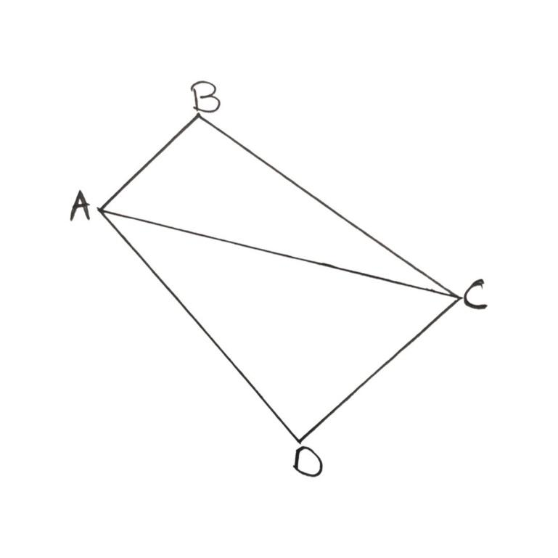

Thus, it follows that, we can draw the quadrilateral, by then splitting it into two triangle ABC and ADC and constructing them, since we now have all the sides. We would thus follow the same process as in constructions of triangles earlier.
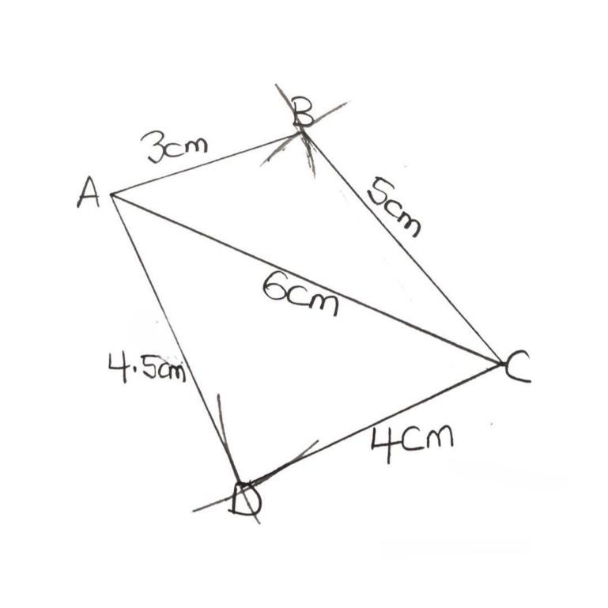

METHOD II: THREE KNOWN SIDES AND TWO DIAGONALS
EXAMPLE:
Construct a quadrilateral PQRS such that QR= 4cm, PS= 5cm, RS= 4.2cm and the diagonals are PR= 5cm and QS= 6.5cm. As done earlier, let’s have a rough view of the diagram.
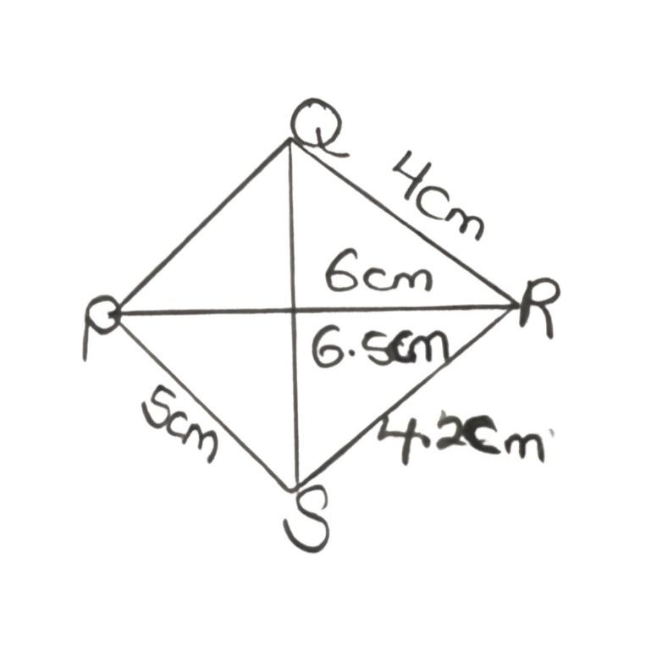

From the rough sketch, we realize that only $∆RQS and ∆PRS have complete side value, thus,$ we can proceed first by constructing either one of them.
Using $∆RQS,$
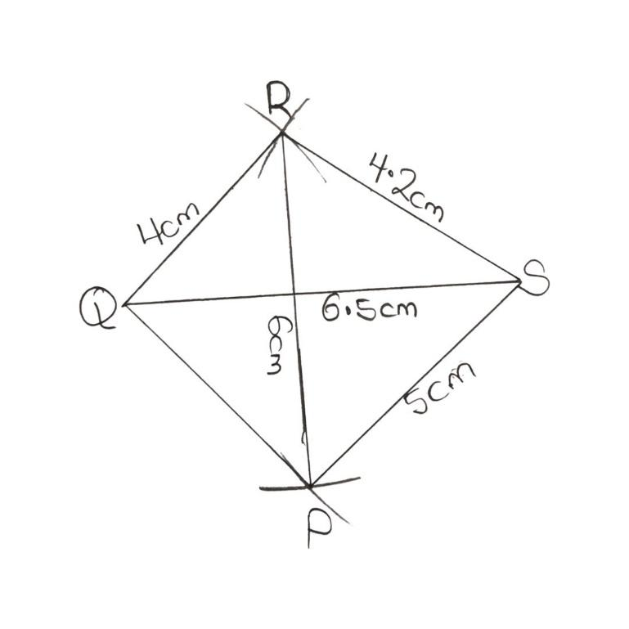

Then from R, we extend the compass by length 6cm and make an arc, and then from S, extend the compass by length 5cm and intersect the arc. This gives us point P. (i.e. PR= 6cm, PS=5cm from question). Join the lines and the quadrilateral is formed.
METHOD III: TWO KNOWN ADJACENT SIDES AND THREE KNOWN ANGLES.
EXAMPLE:
Construct a quadrilateral ABCD where sides AB= 6cm, AD= 3cm
<A = 80$°$, <B=65$°,$ <D= 120$°$
By rough sketch,
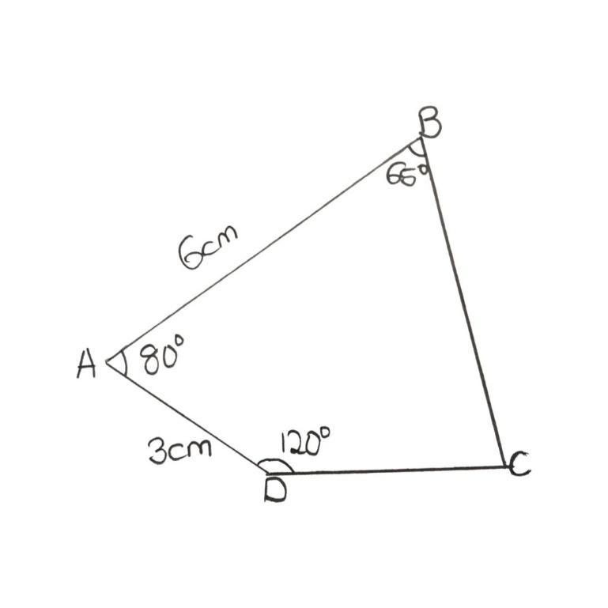

We can utilize the protractor to help generate the accurate angles. From, our rough sketch, the two adjacent sides are in between two angles each. Thus, we can choose any of them are our base line or line segment.
Choosing AB,
- Draw AB with the ruler
- Mark out <A with the protractor, then connect with a ruler.
- Cut an arc on the line in II, with the compass length at 3cm.
The point of intersection on the arc with the line is D (since AD= 3cm)
- At B, mark out <B with the protractor, then extend the line with ruler.
- At D, mark out <D with the protractor, then extend the line with ruler.
- The point where the lines in IV and V meet is C, thus completing the quadrilateral.

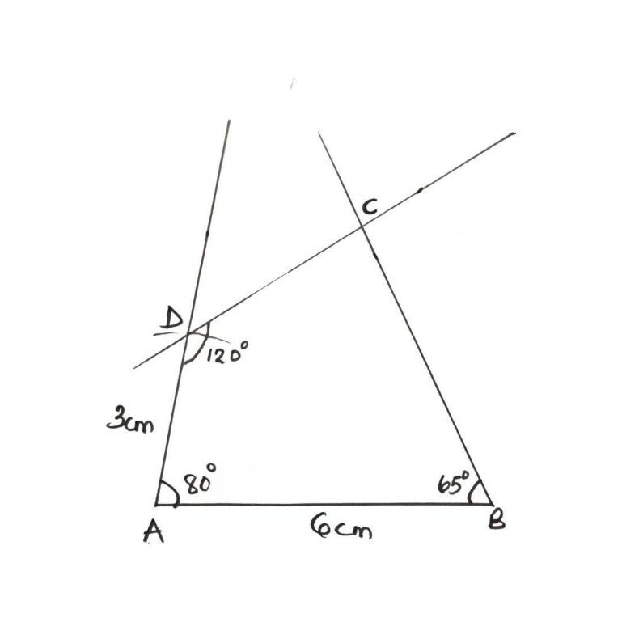

METHOD IV: THREE KNOWN SIDES AND TWO ANGLES
Construct a quadrilateral PQRS such that PQ= 5cm, QR=6cm, RS= 7.5cm and <Q= 105$°$, <R = 80$°.$
For rough sketch,
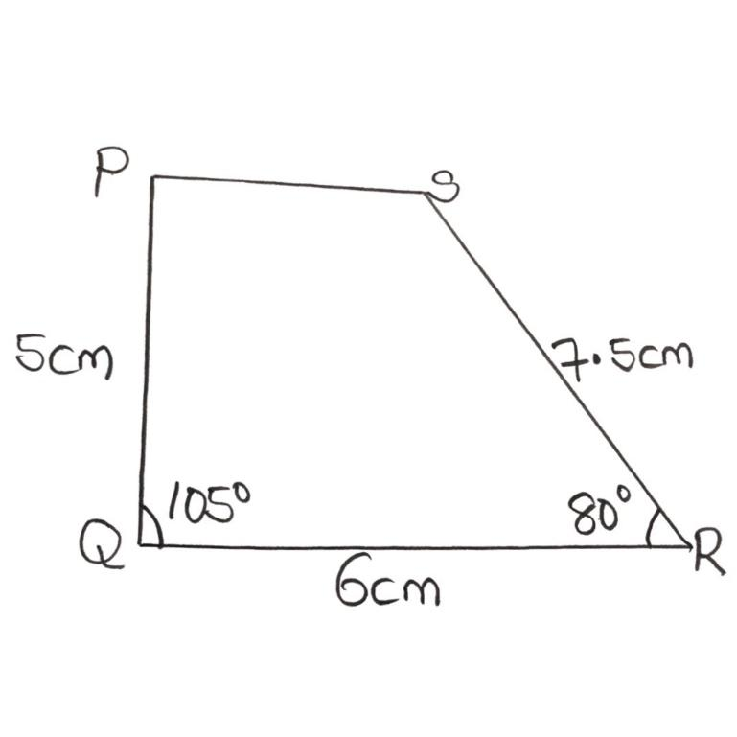

To construct, we begin with the side in between two known angles. In this case, QR. Then, use the protractor to from 105$° and 80°$ at Q and R respectively, while extending the line.
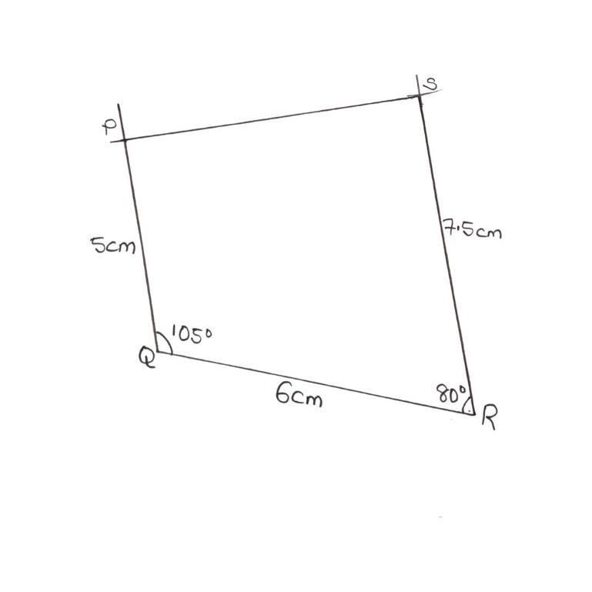

Use the compass to cut an arc length 5cm from Q to form p; then arc length 7.5cm from R to form S. Join points P and S to form the quadrilateral.
DRILL
Construct an equilateral triangle ABC of any length, with ruler and compass only.
SOLUTION
The equilateral triangle is a triangle where each of its angles are 60$°$ and the sides are all equal length. That is, for any equilateral triangle, the angles are ALAWYS KNOWN, and the construction follows the same pattern with only the side length changing.
Let’s use a length of 6cm for instance. We can easily use the (“One known side and two angles”) method.
After completion, measure the other sides to check if they are also of length 6cm and that the third angle is also 60$°.$
